Volunteer and Research Coordinator

Kristal Cerga

McMaster Science Society

2019-2020
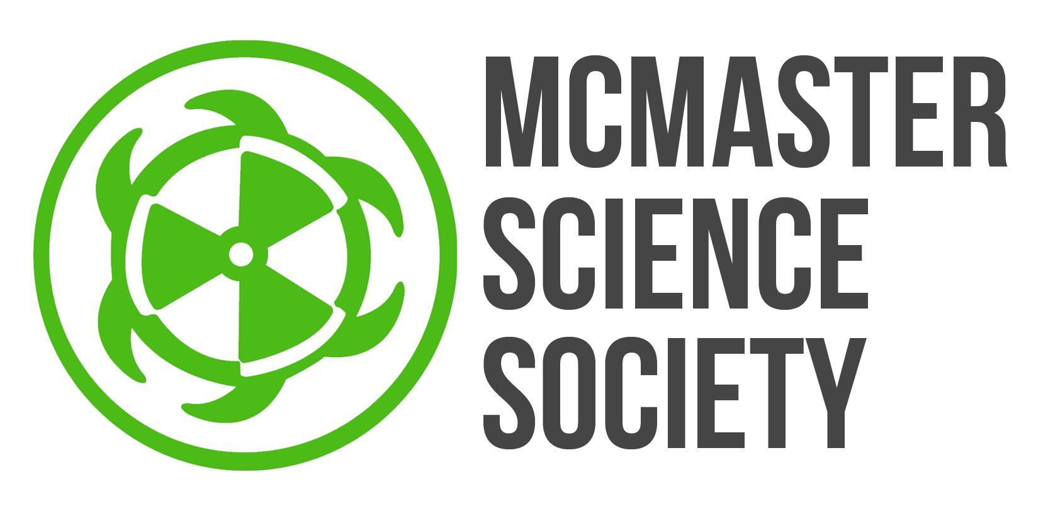
(submitted July 14, 2019)
2019-2020 Year Plan
Letter from the Volunteer and Research Coordinator

Hello hello! My name’s Kristal Cerga, and I’m so ecstatic to be your Volunteer and Research Coordinator for this year! I think there’s so many ways to enrich your experience as an undergraduate student beyond academics, and science students in particular have so many opportunities to be able to do so.
Last year’s coordinator, Doris Adao, ran an incredibly successful research networking event for its first year, as well as worked tirelessly to lay the groundwork for a database of information to be used by science students. Not only am I so excited to be putting on Symbiosis again for its second year, but I want to continue to make sure that opportunities in the community are being adequately communicated to students Most of all, I want to ensure that every student is well equipped with the tools and skills they might need if and when they decide they do want to pursue a research or volunteering position.
My hope for this year is to be able to make sure all sorts of opportunities and resources are completely accessible and to incite excitement and enthusiasm about involvement in volunteering and in research! I want to be able to provide interactive and hands-on events that are helpful to students while providing key insight into how to get involved, whether that’s through research, volunteering, clubs at McMaster, or anything else.
If you have any questions, concerns, or suggestions, I want to hear them, so please never be afraid to reach out! I’m here to provide as much support as I can, and I’m so honoured to be in a position to be able to do so this year. <3

Kristal Cerga
McMaster Science Society Volunteer and Research Coordinator
researchandvolunteering@mcmastersciencesociety.com

OBJECTIVES:

Carrying out Symbiosis for its second year.
Description/Current State | Symbiosis is a networking event in research that aims to connect students with upper years and graduate students about a number of topics, without the added stress of making an impression on established faculty/professors. It was extremely successful, and I’m so excited to bring it back this year!
Goal | To expand upon Symbiosis’ success, as well as budget and plan for its magnitude.  - Begin planning and budgeting early on, in the summer  - Review transition reports and comments from previous coordinator to adequately analyze past costs, budget expenses, and plan logistics of event  - Reaching out to more potential partners for the event, outside of student researchers  - CityLab, SCCE, etc.  - Potentially finding another venue that may be more cost effective, but still maintain a professional atmosphere
Barriers to Success | Lack of student interest  - Students may not be considering research placements/opportunities so early in the school year  - If timing of event is close to midterms, students will likely opt to prioritize studying  - Gives poor impression to researchers about state of involvement on students’ end  Budgeting  - Symbiosis was a complete success in its first year, but some costs could potentially be cut in order to put less of a strain on available resources  - Balancing need for a lively, professional atmosphere with potential budgeting constraints
How? | Advertise event specifically towards needs of each class of science students, with the help of the Communications Team and VP External  - First years; exposure to research  - Second years; opening up research opportunities prior to, and outside of theses (i.e. practicums, research placements, etc.)  - Third years; event provides insight into future thesis projects  - Fourth years; event allows for relaxed environment to discuss their own research, or explore research areas of interest  Carefully review transition report  - It’ll be important to contact potential venues early on, and to hopefully find a cost-effective, and suitable venue/plan  - Cost-benefit analysis of last year’s spending on event
Long Term Implications | - Strengthening connections between science students and researchers  - Encouraging excitement towards involvement in research  - Exposure for labs and research venues on campus/in Hamilton
Partners | Randy Su  VP External  vpexternal@mcmastersciencesociety.com  Sam Marchetti  vpcomm@mcmastersciencesociety.com  VP Communications and Communications team  Jonah Hill  sponsorshipandfundraising@mcmastersciencesociety.com  Sponsorship and Fundraising Coordinator  Katheryne Stewart  steak17@mcmaster.ca  Career Development and Relationship Manager, SCCE  CityLab, Innovation Park, and other organizations  Science faculty and student researchers

Ongoing research workshops.
Description/Current State | Currently students who make the decision to pursue a position in research may find that the lab or position they’re applying to requires specific skills that they don’t not yet possess. Ongoing research workshops will hopefully be able to provide these skills (technical skills, soft skills, or otherwise) to students in order to allow their applications to stand out, and be more competitive.
Goal | Host three workshops per semester, with one workshop of those three being more technical/wet-lab in nature.  - Will provide students with opportunities to accrue specific skills that labs/research positions look for  - Provide exposure to specific lab techniques, skills, and equipment  - Encourage excitement for research through hands on and involved learning opportunities
Barriers to Success | Faculty involvement  - Some professors may be reluctant to open up their labs to students; a strain on costs, resources, and space  - Professors are also busy and can be hard to get a hold of  Student turn out  - Timing events close to midterms of popular classes may affect the overall turnout
How? | Begin contacting faculty early on  - Connect with undergraduate program advisors  - Establish communication with potentially willing faculty/professors  - Reaching out to grad students/doctorate students involved in research  Mindfully planning for events around students’ schedules  - Being aware of busier seasons during the school year  - Many research positions (especially for the summer!) tend to open up in late winter/early spring  - Ensuring research workshops are providing key skills that labs may look for prior to application deadlines  - This will ensure student applications stand out and are competitive  Semester 1-  Workshop 1: Intro to Research  - Areas of research in science  - McMaster Labs  - PI’s on campus  - Resources, contacts, and resume tips  Workshop 2: Quantum Leap Team-Up  - Promo for Quantum Leap  - Finding way in research  - Honing in on personal interests  Workshop 3: Lab Tour and Skills  - Lab tools, setup, and equipment  - Tour of lab  Semester 2-  Workshop 4: Computational Skills  - Purposeful use of databases  - Conducting meta analysis  - Data/statistical tools  - Coding resources  Workshop 5: Communicating Research  - Structuring a paper, and poster-boards  - Research case competitions  - Getting published  Workshop 3: Lab Tour and Skills  - Lab tools, setup, and equipment  - Tour of lab
Long Term Implications | - Fosters positive relationships between faculty/professors/researchers and science students
Partners | Randy Su  VP External  vpexternal@mcmastersciencesociety.com  Katheryne Stewart  steak17@mcmaster.ca  Career Development and Relationship Manager, SCCE  Faculty of Science  Undergraduate Program Advisors

EVENTS & PROJECTS
Symbiosis
DATE | Late October
PURPOSE | Networking opportunity for students interested in research.
PROCEDURE | This event will be held in a professional setting. Fourth year students will provide information about their research projects. External partners can also attend, to provide new insight/potential opportunities beyond just the McMaster research community.
DIFFICULTIES | Budgeting costs, finding speakers, ensuring successful turnout
PARTNERS | Thesis students/graduate students, SCCE, CityLab, MSS executive, volunteers
PROJECTED OUTREACH | 300 total students in attendance, including attendees and presenters
BUDGET | 800.00

Research Workshops
DATE | Ongoing; late September, October, November, and late January, February, and March
PURPOSE | Provide hands on skills and tools needed to successfully pursue a position in research.
PROCEDURE | Workshops to be held once a month per semester, save for the month of exams. Students from all years will be welcome to partake, and faculty/researchers will host workshop lessons that will allow a student’s application to be more competitive and compelling.
DIFFICULTIES | Finding suitable speakers, securing willing faculty to host workshops, ensuring successful turnout
PARTNERS | Science faculty, undergraduate program advisors
PROJECTED OUTREACH | 50 per workshop
BUDGET | N/A

GOALS TO STRIVE FOR
5 things that you wish to have prepared for the beginning of September:
- Contact faculty/professors about potential involvement in research workshops
- Decide themes for each individual research workshop
- Logistics of Symbiosis
- Plan potential involvement/collaboration with Quantum Leap Coordinator and team
- Hash out ideas for ongoing informative posts to MSS site
5 things to be completed during the fall term (1st):
- Host booth at ILSD
- Three research workshops, with one hopefully being a more involved lab demonstration, and one in collaboration with Quantum Leap Coordinator
- Symbiosis!
- Draft and create posts about applying to research and volunteer positions for MSS website
- Fall progress report
5 things to be completed during the winter term (2nd):
- Three more research workshops
- Potential involvement/representation in Quantum Leap conference
- Draft and create posts about applying to research and volunteer positions for MSS website
- Create transparent transition report (outlining problems, successes, etc.).
- Create transition package containing long-term projects that may extend to successor’s term.

TIMELINE
Month | Objective/Project/Event/Goals
June | Completing year-plan and finalizing budget.
July | Reach out to faculty, and partners in the community that may be interested in participating in Symbiosis or workshops.
August | Logistics planning for workshops and Symbiosis; touch base and collaborate with Quantum Leap coordinator about potential partnership
September | Advertising and promotions for Symbiosis; host first workshop at the end of September; meet with SCCE to address the needs of science students and research opportunities, as well as discuss OscarPlus opportunities database
October | Symbiosis in late October; host second workshop
November | Third and final workshop
December | MSS infographics/posts about applying to research positions (external research applications are normally released around this time and are due in early spring of next year)
January | Meet with SCCE; finalize details of Quantum Leap involvement; first workshop of second semester
February | Second workshop of second semester
March | Third and final workshop
April | Transition report completed

