YEAR PLAN

MacSci Minutes Coordinators

Morgan Porteous, Lauren Vamos, Sohnia Sansanwal and Lee-Ran Goodman

McMaster Science Society

2019-2020
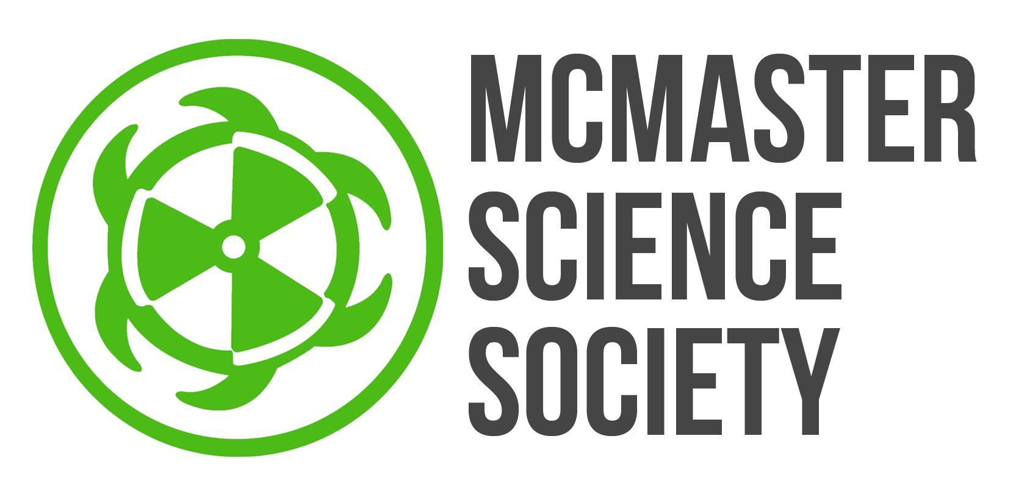
(submitted June 15, 2019)
2019-2020 Year Plan

Letter from the MacSci Minutes Coordinators

Dear McMaster Science,
We are very excited for the opportunity to be your MacSci Minutes Coordinators for the 2019-2020 school year. This role has grown significantly in the past year and has gathered more attention by the MacSci community. We hope to continue this growth and help make the MSS more accessible and transparent. We want MacSci Minutes to become a more pervasive means of communication that MacSci students are able to continuously rely upon for updates, information, and entertainment. Since these are still relatively new positions, we’re excited about the creative freedom we’ve been afforded and the opportunity to grow and expand our viewership.
The MacSci Minutes team gained more attention in the past year by creating videos on a more consistent basis, with content that was relevant and relatable to general MSS members. We want to make more contact with general MSS members so we can get their feedback and input on videos.
We are a service created to enhance communication between the MSS executives and general members. For this reason we want to create video content that appeals to a wide audience. We hope to increase participation from our viewers in our videos and output content that they have requested.
Following in the tracks of previous years, we wish to create videos utilizing interviews of students and staff. However, this will only comprise a limited portion of our video content. We also intend to create videos that inform the science student body about any events or announcements made by the MSS or SRA Science. It is our goal to establish MacSci Minutes as a fun and entertaining way for students to enjoy a quick study break between schoolwork.
We hope that MacSci Minutes videos will provide common ground from which McMaster science students can start conversations and feel connected to their faculty. Partly inspired by videos such as Buzzfeed and NowThis!, we want to create shorter videos which will be aired frequently and consistency. We also wish to include more graphics and closed captions, so that they are fun and easy to watch. We will also dedicate a part of the video for announcements on behalf of the MSS or SRA Science.
Finally, this year there are four (4) MacSci Minutes hosts, which is more than we’ve had in previous years. We were hired in two teams-- Morgan and Lauren, and Lee-Ran and Sohnia. We intend to make some collaborative videos, but we will also be creating some videos as two separate teams. In light of this, we want to ensure there is consistency among all the videos and we want to establish an overarching tone for all videos, no matter the hosts.
Once again, we are looking forward to being the voice of the MSS to the student body. Thank you for taking your time to read our plans for this upcoming year.

Sincerely,
Lee-Ran Goodman, Sohnia Sansanwal, Morgan Porteous and Lauren Vamos
macsciminutes@mcmastersciencesociety.com (Morgan and Lauren)
macsciminutes2@mcmastersciencesociety.com (Lee-Ran and Sohnia)

OBJECTIVES:

Attracting the Interest of Science Students
Description/Current State | MacSci Minutes is the video channel for the MSS. As coordinators, we pitch ideas for videos, write scripts if necessary, and we also host the videos. Last year, most videos were unscripted, as that seemed to make them less formal and more interactive. Despite this, all videos were prepared for and structured with specific ideas and a clear vision.  - Reasonable view count (1K~2K views)  - Content primarily had interviews and audience interaction
Goal | We want to increase our viewership. We want to reach a broader audience and create content that appeals to the masses and has themes and topics that appeal to a variety of audiences.
Barriers to Success | One barrier to success will be tunnel vision. The hosts as individuals have their own areas of interest and senses of humour, so it might be difficult to take a step away from that. It will be important to consider what people who are unlike ourselves might want to see in a video and what humour might appeal to them. That being said, in order to produce genuine and engaging content, we will also need to have a personal interest in it and desire to create it. Thus, it might be difficult to strike a happy medium in this area.  Communication may be another barrier to success. In order to implement this initiative effectively we will have to reach out to third parties and gain information about their interests and what they would like to see in the videos. It will also be necessary for us to effectively communicate within our own team of MSM hosts, so that we’re all on the same page about what we’re creating and why.  Finally, creativity may also be a barrier to success. Last year, the MSM channel was revamped and we created a lot of new videos with many different topics and themes. Most of these videos were popular and well-received. This year, it may be difficult to come up with new and creative ideas that are different from last year, but equally, it not more, successful.
How? | - Have regular meetings with all of the MSM hosts and try to brainstorm new ideas  - Send out Google Forms to the public to see if they have any suggestions for videos  - Reach out to the entire MSS team and see if they have any video ideas  - While interviewing people for other videos, take a minute to talk to them in person about what they might like to see in future MSM videos
Long Term Implications | If we are able to connect with a larger audience, we will help MSM gain attention and recognition as an appealing and helpful tool. Ideally, this will help create a well-informed student body that is knowledgeable about the affairs of the MSS as well as other activities happening on campus and in the general science community. This will also help increase transparency and accountability within the MSS.
Partners | Cinematographers- Saadia and Maria R  Sam Marchetti-- VP Communications  Nicole Wong- Social Media Director

Increasing Student Involvement
Description/Current State | In the past year, most of the MacSci Minutes videos had interviews and audience participation. The statistics around our viewership revealed that the videos that contained interviews of random students, especially in busy locations (such as Thode Library) had more consistent viewers than videos without audience participation.
Goal | We want to create more videos based on student input! The purpose of this service is to effectively communicate to the general MSS community. For this reason, we should be creating videos with topics that they have asked for. In order to accommodate this, we can:  -Send out feedback forms  -Ask them to email us  - Invite them to MSS meetings  -Invite them to meet with us  -Create a small contest to be a MSM host/guest for a day  Achieving this goal will allow students of the MSS to destress in the midst of dealing with their academic workloads. It will also allow students to identify more with the McMaster Science community, and perceive the McMaster Science Society as an approachable organization. MacSci Minutes videos will allow science students to start conversations and bond with each other. Furthermore, MacSci Minutes videos will keep McMaster science students up-to-date with the current activities and upcoming events within the community, such as Formaldehyde and I Love Science Day.  Thorough planning of MacSci Minutes videos and punctual communication with the MSS videographers will allow the achievement of this goal.
Barriers to Success | One of our biggest barriers to success will be communication. We will need to plan proactively and effectively. We’ll have to coordinate with each other to assign video ideas to avoid overlap. We’ll also have to communicate with the cinematographers to schedule times to film.  Things to consider:  -Schedule filming with cinematographers  -If there’s a specific release date for the videos, ensure the cinematographer has enough time after filming to edit the video  -Communicate with social media director to ensure the intended date of video release doesn’t conflict with anything
How? | We will have to be proactive in our communication. We’ll have to schedule meetings, filming, and video content ahead of time and stick to our schedule. We will keep lines of communication open between all MacSci Minutes Hosts and also the cinematographers, as well as all executive members of the MSS.  We will use tools such as:  -Slack (General MSS and Comms)  -Facebook  -Google Calendar  -Email  -Google Documents
Long Term Implications | We want to establish a more transparent relationship between general MacSci members and the MSS. We want to become a point of contact for MacSci members, so we can start to bridge the gap between the MSS executives and general members. We also want to help the MSS gain a better reputation as a more relatable group that cares about the same thing as the general members and can provide fun and relevant entertainment for viewers.
Partners | Cinematographers- Saadia and Maria R  Sam Marchetti-- VP Communications  Nicole Wong- Social Media Director

Increasing Awareness of MSS Affairs
Description/Current State | Previous MacSci Minutes videos were separate from other operations within the MSS, such as the MacSci Musical or Formaldehyde.  - Videos revolved around holidays instead (e.g. New Year’s Day, Halloween)  - Videos sometimes included scientific explanations to various phenomena
Goal | To increase awareness of various MSS events/activities and opportunities for involvement with the MSS  - At the end of each MacSci Minutes Video, dedicate a section of the video to inform students of current MSS news  - Raise awareness for MSS elections, Formaldehyde, MacSci Musical, I Love Science Day, SRA Updates, etc.  - If possible, ask the relevant MSS executive/SRA member to star in the video  Effective communication between the MacSci Minutes team, the MSS Executive Team and the Student Representative Assembly will allow the achievement of the goal.
Barriers to Success | A barrier to success would be the MacSci Minutes team not being completely aware of the internal operations and events running within the MSS at any given time.  Another barrier to success would be the inability of the MSS Executives that are relevant to the event/announcement to partake in the MacSci Minutes video. (Although it is expected that not all individuals that we ask to star in our video will be able to do so.)
How? | The first barrier may be overcome by ensuring that the MacSci Minutes team attend the biweekly MSS meetings and stay updated on what to put on the videos regarding any relevant, upcoming events.  The second barrier may be overcome by either having a MacSci Minutes Coordinator talk about the event/announcement in question him/herself or have the relevant MSS Executive member/SRA Member talk about it through a recorded video separate from the production of the MacSci Minutes video.
Long Term Implications | This goal will increase overall turnout of science students to events, voting, auditions and applications. It will also give students knowledge on any important policy the Student Representative Assembly wishes to advocate.
Partners | The MSS Executive Member relevant to the event/announcement being made

EVENTS & PROJECTS
MacSci Minutes videos
DATE | Biweekly, from September to April
PURPOSE | To provide McMaster science students with entertaining, relatable content on a regular basis, and to provide a cohesive public image of the MSS
PROCEDURE | - Discuss ideas  - Generate storyboard (and script, if necessary)  - Meet with cinematographers to outline production, schedule filming times  - Film the video  - Collaborate with the cinematographers to edit and finalize the video  - Communicate with graphic designers for necessary graphics  - Release the video on youtube. Share via MSS facebook page and website, and in various McMaster science facebook groups  - Ask all MSS members to share and promote the videos  - Rinse and repeat
DIFFICULTIES | - Finding meeting times that will work for everyone  - Completing the project without any tangible deadlines - we must be very self-motivated and set internal deadlines  - Coming up with new and creative content
PARTNERS | Cinematographers and VP Communications
PROJECTED OUTREACH | The McMaster Science community
BUDGET | $150 may utilize MSS swag for contests or video props

GOALS TO STRIVE FOR
5 things that you wish to have prepared for the beginning of September:
- Have at least one pilot episode produced
- Have plans/storyboards for future episodes
- Formulate a tentative schedule for release and filming times
- Maintain a good working relationship with the cinematographers
- Review year plans of the Student Representative Assembly and the MSS executive, and identify events/information that require advocacy through the MacSci Minutes videos
5 things to be completed during the fall term (1st):
- Have several individual and collaboration episodes released (6-8 episodes total)
- Release an informal survey to evaluate responses to current MacSci Minutes content and to receive suggestions for future content
- Apply survey feedback into future content
- Incorporate the Formaldehyde Coordinator, VP Internal (First Year Rep elections), musical coordinator, Special Events Planner, Arts Director, Athletics & Wellness Director, SIF Coordinator and Student Representative Assembly into videos
- Establish relationships with the executive members of the MSS and gain a better understanding of their roles and responsibilities. This will better enable us to help promote their events and initiatives.
5 things to be completed during the winter term (2nd):
- Even more individual and collaboration episodes released (6-8 episodes total)
- Incorporate Quantum Leap Coordinator, Musical Coordinator and Student Representative Assembly into videos
- Promote MSS Graduation Scholarships
- Complete transition reports for the incoming MacSci Minutes team
- Produce a “bloopers”video

TIMELINE
Month | Objective/Project/Event/Goals
June | - Communicate with cinematographers to discuss production process and time availability  - Produce Pilot Episodes
July | - More Pilot Episodes
August | - More Pilot Episodes  - Film Video during Welcome Week
September | - Weekly videos  - Release Welcome Week Video  - I Love Science Day video
October | - Weekly videos  - Release Midterm Season Video
November | - Weekly videos  - Promote SIF
December | - Weekly videos  - Promote Formaldehyde  - Release Exam Season Video
January | - Weekly videos  - Formaldehyde Recap
February | - Weekly videos  - Promote Quantum Leap  - Promote What To Do in Level II  - Release Midterm Season Video
March | - Weekly videos  - Pi Day video
April | - Weekly videos  - Release Exam Season Video  - Help the next MacSci Minutes Team transition

