YEAR PLAN

Directors of Photography

Sahil Karnani | Alexis Chacon

McMaster Science Society

2019-2020
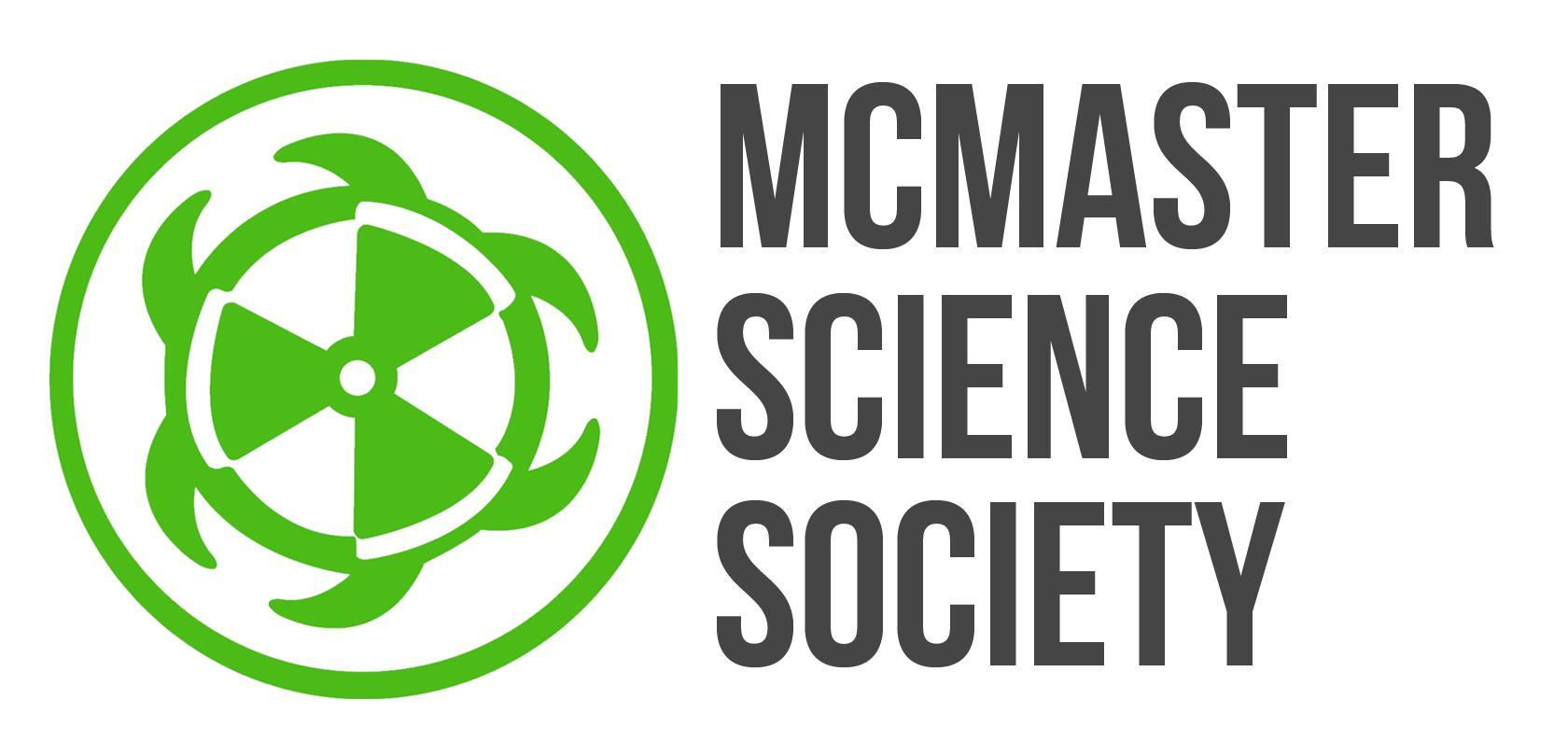
submitted June 29, 2019
2019-2020 Year Plan
Dear McMaster Science Students,
We are Sahil Karnani and Alexis Chacon, your new Directors of Photography for the McMaster Science Society for this year of 2019-2020. We are excited, and more than ready to begin capturing and showcasing what McMaster Science is all about. McMaster Science primarily runs for the students, and by being able to showcase your talents, and yourselves, we can offer a glimpse as to what science at McMaster is all about.
Last years Directors of Photography, Chris Simon and Reta Meng worked hard to capture various MSS events while showcasing personal stories of students to create a stronger sense of community within the faculty of science. Their projects, including Scientists of McMaster, and the LinkedIn photoshoots, were successful, and can be continued for further development.
For the Scientists of McMaster project, we plan to try to get in contact with several scientists across the McMaster campus, and showcase their stories, by giving some perspective on their time at McMaster, what type of science they are fascinated by. As for the LinkedIn photoshoots, we hope to increase accessibility and volume of LinkedIn photo shoots that take place throughout the year, so that the most McMaster Science students can use this service, at their disposal.
Additionally, we plan to do a Humans of Thode series, built around our McMaster Science students, so we can showcase our science students hard at work, in one of the biggest libraries on campus.
Our hope is to expand our work to reach as many McMaster science students as possible, by engaging and interacting with students in different environments all across campus. By showcasing our students, we hope to build a greater perspective as to just how unique and special the McMaster Science community is.

Sahil Karnani Alexis Chacon
Co-Director of Photography Co-Director of Photography
photography1@mcmastersciencesociety.com
photography2@mcmastersciencesociety.com

OBJECTIVES:

Scientists at McMaster
Description/Current State | Within the science faculty, there are various departments, and fields of research that McMaster Science members showcase their talent in.  - A photo series showcases scientists across campus, in the various departments within the faculty of science  - Each photo would display the scientist (preferably in their work environment), and additionally a caption will be provided that will provide some background information and thoughts from the scientist (what they do for a living, some problems they may have encountered, some of their achievements, etc.)
Goal | - Reach a larger audience so more people are aware of the events, opportunities and resources the MSS provides by increasing the number of social media posts, posters and class talks  - Encourage students to reach out when they have any questions, problems or in need of advice by creating a “safe space” within the community  - Promote the importance of mental health and balancing school work to minimize stress by having more people share their stories and advice for other people going through the same thing  - Try to get younger researchers featured on scientists of McMaster, in hopes to attract a younger demographic to the content  - By doing so, it ultimately provides science students across campus with insights into different career paths  - It also provides science students the ability to resonate with another person, as they may be going through a similar thing that the scientist/researcher is going through as well  - hopefully, it may lead to students reaching out to get involved within the McMaster science community at a larger level, such as wanting to get involved in research that interests them  Strengths:  - By being organized, it allows us to plan each of the sessions in advance  - By being diligent and having a strong work ethic, we can continue reaching out to scientists across campus, in order to showcase the scientists of McMaster at high volumes
Barriers to Success | Some barriers which we may cross are:  - It may be difficult to reach out to a variety of labs: due to time constraint of researchers/students  - There may be a large demand to be featured  - Coordinating with interested candidates and collaborating with social media coordinator to publish posts regularly
How? | How do you plan to overcome the barriers mentioned above in order to reach your goal(s)?  - Reach out to various faculty societies to try to connect with research coordinators to gain more information about labs in various departments  - Reach out to professors, or lab centers/institutes across campus, in order to obtain information on individuals willing to be showcased  - Try to maintain constant contact with interviewees, in order to make sure plans do not fall through  - Plan and communicate well in advance with the interviewees, in order to handle the demand to the best of our abilities  - Plan and communicate well in advance with the Social Media Coordinator, to publish posts according to schedule
Long Term Implications | - Possibly give more insight into different career paths that science students can go into  - Increase faculty involvement  - Connection between students and professors on a higher level  - Possibly can be used for student’s trying to obtain research positions in some labs
Partners | - McMaster Science students  - Sam Marchetti (VP Communications)  - Nicole Wong (Social Media Coordinator)

LinkedIn Photoshoots
Description/Current State | - Provide high quality headshots for students  - Treated as a service provided by the McMaster Science Society  - This is based as a pilot project, that will run for a short time at first, but then has the option to be extended to run throughout the full academic year.
Goal | What you hope to improve  - Improve efficiency of the whole project; increase the volume of headshots taken for students while maintaining high quality standards  - Outreach to new students, by using promotions to hopefully allow more students to gain access to this service
Barriers to Success | - Many people may be interested in this, resulting in high levels of demand  - Distributing photos may be a challenge
How? | - By organizing well in advance when we can do LinkedIn/ photoshoots for students, we can try to accommodate for the large levels of demand  - For distribution, when they request for a session, we can take their email, and email the photos back to them, primarily using google drive and gmail to store and distribute the photos
Long Term Implications | - Allow science students to recognize the service as a primary choice/resource for them to get professional photoshoots
Partners | - McMaster Science students  - Social Media Director; to promote (Nicole Wong) and VP Communications (Sam Marchetti)

Humans of Thode
Description/Current State | - New project in the works; adapted from a student who gave permission to continue with the series  - In development for the school year  - To showcase our science students hard at work and interacting with friends, in one of the biggest libraries on campus.  - This is a photo series, which is based around an artistic take of photography, which can be used for students to enjoy and post on their own social media platforms.  - This is also a fun/interactive project for science students to engage with during the stressful exam season, which can be beneficial to students, and could make them happier!
Goal | - Used as a creative output in order to interact with science students, and catch a glimpse into their everyday lives  - To be developed into a series, which simply shows our diverse student group being represented all having a common ground: studying (or at least trying to)  Strengths:  - As this is a creative output, it allows us to have a little more creative freedom with who we choose to take pictures of, as this is a series to be developed  - It is based on a flexible time schedule, so it does not have to be set for pictures needing to be posted at all times, photos can be taken on a rolling basis throughout the semester  Weaknesses:  - Due to large amounts of demand in the past from a past student, if this may continue, we may be dealing with a large amount of requests.
Barriers to Success | - There may be too many, or too few people wanting to get involved
How? | - To achieve this, we will reach out to students who are studying; first primarily friends, but once it gains traction, students we may or may not know  - Continuously take pictures throughout the semester, but heavily emphasized during exam time  - By going around the library, asking if they’re willing to be featured in Humans of Thode
Long Term Implications | - As this is a series adapted from a previous student, we can possibly integrate this as an MSS creative project  - Allows us to showcase a larger number of students within the faculty, not only the students in labs doing research  - Can potentially lead to an increase in McMaster Science Society engagement  - Can potentially increase the demand for students wanting to be featured on McMaster Science social media, possibly leading to a stronger following with students
Partners | - McMaster Science Students

GOALS TO STRIVE FOR
5 things that you wish to have prepared for the beginning of September:
- MSS exec headshots taken and edited
- Drone license and software needed purchased
- Become proficient in taking photos, editing and ensuring all of the photos are edited similarly
- Contact labs, faculty societies, and professors for Scientists @ Mac
- Have a comprehensive understanding of the year plan and our duties on the MSS
5 things to be completed during the fall term (1st):
- Initiate Scientists @ Mac and Research at Mac
- Plan and begin LinkedIn photoshoot
- List all available equipment needed for large events (e.g. formaldehyde)
- Purchase any remaining equipment or software needed
- Be available to photograph MSS and Program Society events as needed
5 things to be completed during the winter term (2nd):
- Continue Scientists @ Mac and Research at Mac
- Plan photography for Formaldehyde, Quantum Leap, Ultimate Arts Show, etc.
- Help out the MSS wherever is needed
- Be available to photograph MSS and Program Society events as needed
- Summary report

TIMELINE
Month | Objective/Project/Event/Goals
June | - Finish and post exec headshots
July | Scientists at Mac  - Start to contact labs, faculty societies, and professors  - Begin to test out and become acquainted to the camera accessories (soft boxes and external flash)
August | - Scientists at Mac  - Continue lab research  - Begin to get a few scientists showcased  - Continue to test out and become acquainted to the camera accessories (soft boxes and external flash)
September | - Scientists at Mac  - Outreach for student stories  - First interviews + photos  - LinkedIn Photoshoot  - Begin promoting this to science students  - Begin to take pictures at students’ requests  - Humans of Thode  - Begin to take photos to start campaign
October | - Scientists at Mac  - Regular posts  - LinkedIn Photoshoot  - Take pictures at students’ requests  - Humans of Thode  - Regular photos being taken
November | - Scientists at Mac  - Regular posts  - Second set of interviews + photos  - LinkedIn Photoshoot  - Take pictures at students’ requests  - Humans of Thode  - Regular photos being taken
December | - Scientists at Mac  - Regular posts  - Second set of interviews + photos  - LinkedIn Photoshoot  - Take pictures at students’ requests  - Humans of Thode  - Regular photos being taken; more than usual due to higher amount of students at Thode Library
January | - Linkedin Photoshoot  - Promote once again  - Scientists at Mac  - Promotion for new stories + scientists  - Begin 3rd round of interviews + photos  - Regular posts  - Formaldehyde  - Plan out Formaldehyde photography  - Quantum Leap  - Plan out Quantum Leap Photography
February | - Formaldehyde  - Quantum Leap  - Linkedin Photoshoot  - Begin to take photos at students requests  - Scientists at Mac  - Regular posts
March | - Scientists at Mac  - Regular posts  - LinkedIn Photoshoot  - Take pictures at students’ requests  - Humans of Thode  - Begin to slowly increase photos being taken
April | - Scientists at Mac  - Regular posts  - Humans of Thode  - Increase photos being taken; more than usual due to higher amount of students at Thode Library

