YEAR PLAN

Policy and Bylaws Officer

Sara Evans

McMaster Science Society

2019-2020
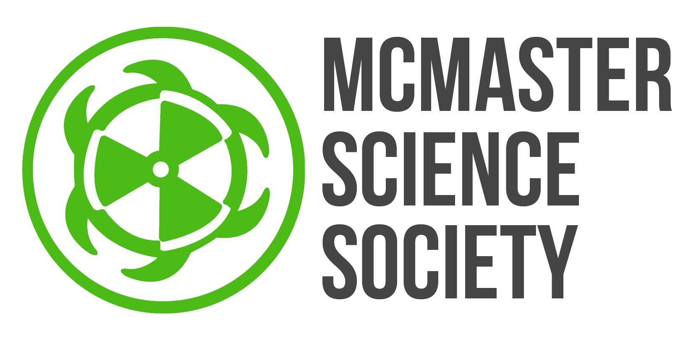
(submitted June 1, 2019)
2019-2020 Year Plan
Dear Science Students,

The role of Policy and Bylaws Officer is a new addition to the Internal Portfolio of the MSS. Last year, MSS VP Internal, Nicole Wong, and MSS Internal Operations Officer, Greg Woodward, worked hard to improve the policies and bylaws of the MSS and decided a role dedicated to this task would benefit the McMaster Science Society. I am very excited to step into this role and continue their great work.

My two main goals for this year are to assist the program societies in ratifying under the MSS and improving the MSS documentation. I plan to meet with the program societies to ensure that their constitutions serve the needs of their society and to ensure they are content with their new place within the MSS family. Each department in the Faculty of Science is unique, and their societies reflect that. I also wish to improve the documentation of the MSS. I will be creating a history to better understand our progress and determine where we can improve in our policies. There are also chances to improve our policies and bylaws. I will be meeting with the executive members of the MSS to create policies that allow future students in that role to have a clear understanding of their responsibilities and what they must do to achieve them.

In my position, I wish to improve the MSS through better documentation. Please reach out to me if you have ideas, suggestions, or concerns about anything related to the MSS documentation.

Cheers,

Sara Evans
Policy and Bylaws Officer
policyandbylaws@mcmastersciencesociety.com
OBJECTIVES:

Assist program societies with documentation during ratification process
Description/Current State | Previously, program societies were ratified under both the McMaster Student Union and the McMaster Science Society. Recent MSU policy changes means that the program societies must ratify under one or the other. I will be assisting program societies ratify under the MSS by assisting with constitutional amendments.
Goal | - Help each program society amend their constitution to ensure it suits their society needs and meets MSS requirements  - Help program societies throughout the year as they make amendments and write new policies
Barriers to Success | Each program society has different goals and strives to meet different needs for their members. This means that each constitution will have unique elements that must be considered in the ratification process.
How? | I plan to talk to meet with each program society to discuss their constitutional needs and help them develop their own constitution and being open to their ideas.
Long Term Implications | - Stronger program society constitutions  - Open dialogue between MSS and program societies
Partners | - Program society presidents and other executive members  - Reta Meng, MSS VP Internal

Organize and Amend MSS Documentation
Description/Current State | There is currently little documentation on the creation and amendments to MSS documentation.  Also, only some roles on the MSS have a policy outlining requirements.
Goal | - Create a record of MSS documents  - Discuss policies with MSS executive members to write/amend role policies
Barriers to Success | The creation and amendments of MSS policies and bylaws have thus far been fairly undocumented so finding this information might be difficult
How? | - Read minutes from previous MSS years to determine dates.  - Create system to document these dates and the changes made  - Meet with MSS executive members to discuss their policy  - Work with that member to write a policy that accurately represents the position
Long Term Implications | - Better understanding of the history of the MSS  - More defined roles for members on the MSS
Partners | - Reta Meng, MSS VP Internal

GOALS TO STRIVE FOR
5 things that you wish to have prepared for the beginning of September:
- Finish writing the MSS Psychology, Neuroscience & Behaviour Council Policy.
- Provide all program societies with feedback on their constitution.
- Determine amendments to be made to the constitution in preparation for the Fall General Assembly.
- Create a record of MSS policies.
- Create a Google form for students to anonymously submit queries, ideas, and complaints about MSS documentation and how they’re being followed.
5 things to be completed during the fall term (1st):
- Assist with program society ratification under the MSS.
- Draft amendments to the MSS constitution
- Present constitutional amendments at the fall General Assembly.
- Write documentation on the creation and amendments of MSS documents.
- Write easily digestible summaries of MSS policies.
5 things to be completed during the winter term (2nd):
- Assist program societies with year-end constitutional amendments
- Collect feedback from program societies regarding their relationship with the MSS.
- Meet with MSS executive members to discuss the policy relating to their role.
- Amend/write the policy for each MSS executive role.
- Present constitutional amendments at the winter General Assembly

TIMELINE
Month | Objective/Project/Event/Goals
June | - Finish draft of MSS Psychology, Neuroscience & Behaviour Council Policy  - Make notes on program society constitutions
July | - Discuss program society constitutions with MSS VP Internal and the societies  - Create a record of MSS policies
August | - Review the MSS Constitution and determine potential amendments to be made  - Create Google form for student feedback on MSS documentation (to be open all year)
September | - Ensure the program societies have sufficient documentation for ratification under the MSS  - Draft constitutional amendments
October | - Present amendments at the fall General Assembly
November | - Create documentation for the history of MSS policies
December | - Write MSS policy “Sparknotes”
January | - Meet with MSS executive members to discuss their role policies
February | - Present constitutional amendments at the winter General Assembly  - Write/amend MSS executive member role policies
March | - Gain feedback from program societies
April | - Discuss constitutional amendments with program societies

